Pupil premium strategy statement – Little Leigh Primary School
Before completing this template, read the Education Endowment Foundation’s guide to the pupil premium and DfE’s pupil premium guidance for school leaders, which includes the ‘menu of approaches’. It is for school leaders to decide what activity to spend their pupil premium on, within the framework set out by the menu.
All schools that receive pupil premium are required to use this template to complete and publish a pupil premium statement on their school website by 31 December every academic year.
If you are starting a new pupil premium strategy plan, use this blank template. If you are continuing a strategy plan from last academic year, you may prefer to edit your existing statement, if that version was published using the template.

Before publishing your completed statement, delete the instructions (text in italics) in this template, and this text box.

This statement details our school’s use of pupil premium funding to help improve the attainment of our disadvantaged pupils.
It outlines our pupil premium strategy, how we intend to spend the funding in this academic year and the outcomes for disadvantaged pupils last academic year.

School overview
Detail | Data
Number of pupils in school | 147
Proportion (%) of pupil premium eligible pupils | 9.5%
Academic year/years that our current pupil premium strategy plan covers (3-year plans are recommended – you must still publish an updated statement each academic year) | 2024/25
Date this statement was published | November 2024
Date on which it will be reviewed | November 2025
Statement authorised by | LLPS LAB
Pupil premium lead | Rebecca Challinor
Governor / Trustee lead | Alistair Richards

Funding overview
Detail | Amount
Pupil premium funding allocation this academic year | £20,720
Pupil premium funding carried forward from previous years (enter £0 if not applicable) | £0
Total budget for this academic year  If your school is an academy in a trust that pools this funding, state the amount available to your school this academic year | £20,720

Part A: Pupil premium strategy plan

Statement of intent
Create Learning Trust Leaders have developed the following intent through the EEF’s ‘Tiered Approach to Pupil Premium Spending’ (September 2024) and the Pupil Premium Overview (September 2024)
- Ultimately, we are striving for outcomes for our disadvantaged pupils (academic and non-academic) to be in line or better with their non-disadvantaged peers.

- All children in receipt of Pupil Premium funding will have the same exposure to quality first teaching practices in addition to targeted academic support and wider strategies.
- We will treat implementation as a process to prioritise, plan and prepare appropriately.
- Effective diagnostic assessments of our disadvantaged children for academic and non-academic outcomes will be in place.
- Following assessments school leaders will identify who needs intervention to close any emerging gaps and a targeted intervention plan will be produced.
- School leaders will build a culture of clear and sustainable implementation, ensuring the deployment of key staff are working with priority children.
- We will make evidenced informed decisions on what to implement when and by whom.
- We will regularly monitor the impact of additional interventions and strategies used – ensuring we adapt any strategies and processes. These will be monitored and reported termly.
- We will ensure that we evaluate our strategy regularly as what works one year may not work the next year.
- A full review will be conducted annually to evaluate the overarching strategy and measure the success based on outcomes for our disadvantaged pupils. We will report outcomes against a robust and evaluative framework.

- Professional Development will support the implementation of evidence-based approaches to improve outcomes for those in receipt of the Pupil Premium Grant.

Challenges
This details the key challenges to achievement that we have identified among our disadvantaged pupils.
Challenge number | Detail of challenge
1 | Attendance
2 | Academic Achievement & Attainment
3 | Resilience
4 | Financial Challenge for Families

Intended outcomes
This explains the outcomes we are aiming for by the end of our current strategy plan, and how we will measure whether they have been achieved.
Intended outcome | Success criteria
Attendance of PP children will be at least in line with non-disadvantaged pupils. | Insight data shows that attendance of PP children is at least good.  Attendance Policy updated in line with current guidance ‘DfE Working Together to Improve Attendance’ (August 2024)  Key staff in school have strategic responsibility in school for monitoring and improving attendance.  All key documents and school expectations shared regularly with parents e.g. updated policies, newsletters etc.  Staff are aware of potential barriers to learning and ‘push and pull’ factors are considered when identifying strategies to improve children’s attendance  FSW supports targeted families whose attendance is below ‘average’ or at risk of falling below ‘average’
The emotional needs of those in receipt of PP are well supported through targeted intervention and teaching approaches | Children in receipt of PP demonstrate good levels of resilience across their learning, social interactions and play  A range of whole class, group and 1:1 non-academic interventions are employed and delivered e.g. ELSA, Socially Speaking, Commando Joe’s  Termly/half-termly wellbeing team meetings take place to monitor the impact of non-academic interventions and identify candidates for future targeted support.  INSIGHT is used effectively to record interventions and their impact  Impact of intervention indicates increased confidence, resilience and engagement in school life.  This will be evidenced by pupil voice, parent surveys, CPOMs analysis, teacher observations.  Zones of regulation will be introduced across the school to facilitate  Staff trained
Achievement & attainment of those in receipt of pupil premium is at least in line with ‘average’ | Children in receipt of PP make at least good progress and attain well when compared to children not in receipt of PP.  Learners in receipt of PP are monitored as a specific cohort in progress meetings  Learners in receipt of PP are monitored as a specific cohort by leaders at all levels  Next steps and interventions are put in place where gaps are identified or pupils are not making sufficient progress  Additional adults are deployed strategically to positively impact on progress and outcomes  Insight is used to monitor and track progress effectively and record interventions and their impact  Progress meetings at key intervals throughout the year ensure that learners who are not making expected progress or do not meet ARE are identified and swift and effective intervention is put in place.
Financial challenge for those in receipt of Pupil Premium Funding | Pupil premium ensure equal access to the curriculum and wider enrichment opportunities so that finances are not a barrier to learning for children in receipt of PP.

Activity in this academic year
This details how we intend to spend our pupil premium funding this academic year to address the challenges listed above.

Teaching (for example, CPD, recruitment and retention)
Budgeted cost: £
Activity | Evidence that supports this approach | Challenge number(s) addressed
- ELSA Training  - A range of whole class, group and 1:1 non-academic interventions are employed and delivered e.g. ELSA, Socially Speaking, Commando Joe’s  - Termly/half-termly wellbeing team meetings take place to monitor the impact of non-academic interventions and identify candidates for future targeted support.  - INSIGHT is used effectively to record interventions and their impact  - Impact of intervention indicates increased confidence, resilience and engagement in school life.  - This will be evidenced by pupil voice, parent surveys, CPOMs analysis, teacher observations.  - Zones of regulation will be introduced across the school to facilitate | 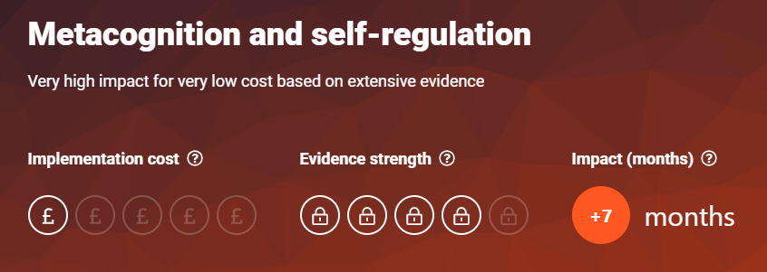  https://educationendowmentfoundation.org.uk/education-evidence/teaching-learning-toolkit/metacognition-and-self-regulation  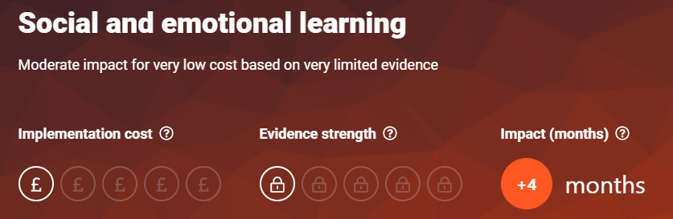  https://educationendowmentfoundation.org.uk/education-evidence/teaching-learning-toolkit/social-and-emotional-learning | 2 & 3
Staff CPD Reading Comprehension | 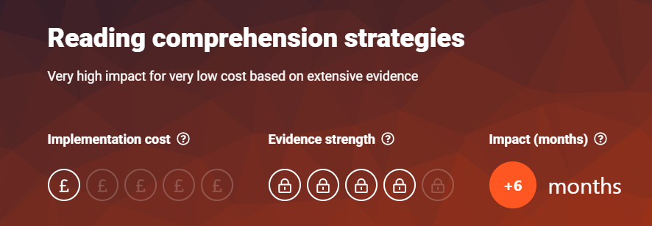  https://educationendowmentfoundation.org.uk/education-evidence/teaching-learning-toolkit/reading-comprehension-strategies | 2
Staff CPD – Guiding Principles | 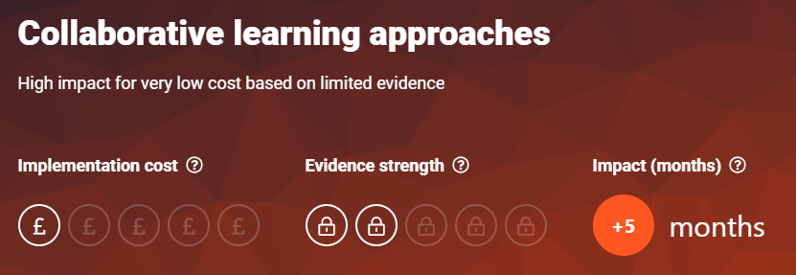  https://educationendowmentfoundation.org.uk/education-evidence/teaching-learning-toolkit/collaborative-learning-approaches | 2
Staff CPD – Zones of Regulation | 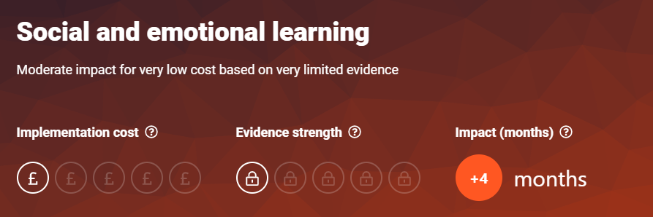  https://educationendowmentfoundation.org.uk/education-evidence/teaching-learning-toolkit/social-and-emotional-learning | 2 & 3
Staff CPD Mastery Learning | 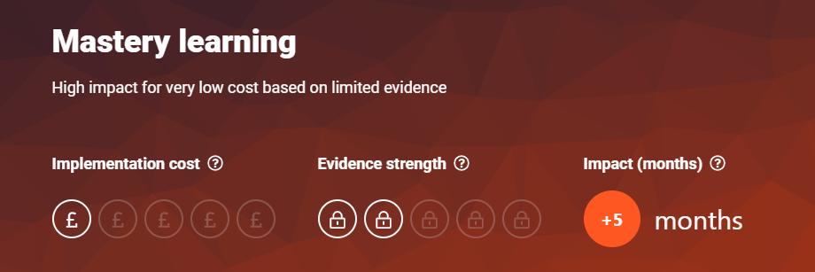  https://educationendowmentfoundation.org.uk/education-evidence/teaching-learning-toolkit/mastery-learning | 2

Targeted academic support (for example, tutoring, one-to-one support, structured interventions)
Budgeted cost: £ [insert amount]
Activity | Evidence that supports this approach | Challenge number(s) addressed

Wider strategies (for example, related to attendance, behaviour, wellbeing)
Budgeted cost: £ [insert amount]
Activity | Evidence that supports this approach | Challenge number(s) addressed
- Family Support Worker employed additional half day per week (1 day total)  - Attendance Policy updated in line with current guidance ‘DfE Working Together to Improve Attendance’ (August 2024)  - Key staff in school have strategic responsibility in school for monitoring and improving attendance.  - All key documents and school expectations shared regularly with parents e.g. updated policies, newsletters etc.  - Staff are aware of potential barriers to learning and ‘push and pull’ factors are considered when identifying strategies to improve children’s attendance  - FSW supports targeted families whose attendance is below ‘average’ or at risk of falling below ‘average’ | 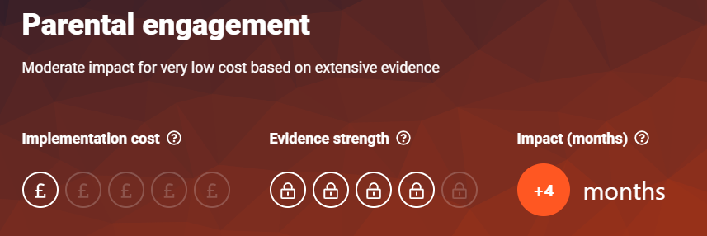  https://educationendowmentfoundation.org.uk/education-evidence/teaching-learning-toolkit/parental-engagement    https://educationendowmentfoundation.org.uk/education-evidence/leadership-and-planning/supporting-attendance  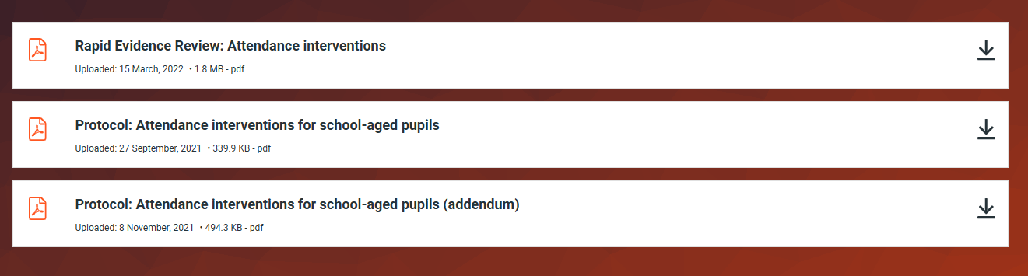  https://educationendowmentfoundation.org.uk/education-evidence/evidence-reviews/attendance-interventions-rapid-evidence-assessment | 1, 2, 3 & 4
Contingency Fund | Based on our experience and those of schools similar to ours, we have set aside a small amount of money which will be used to respond quickly to needs which have not been identified and to ensure equal access to the curriculum and wider curriculum opportunities for all.

Total budgeted cost: £20, 720

Part B: Review of the previous academic year

Outcomes for disadvantaged pupils
PP money was effectively used to support equal opportunities and access for all to the curriculum and wider enrichment opportunities this judgement is supported by attendance registers for curriculum and wider curriculum enrichment opportunities.
Evidence sources show that children in receipt of PP positively engage in learning and wider curriculum opportunities and demonstrate good levels of resilience in their learning, social interactions and play. Where wider needs are identified school has successfully signposted families to and supported families in getting the right support to meet need. There is a continued need for this support in future pupil premium planning.
Progress analysis shows that all learners in receipt of PP funding made at least expected progress.
Further analysis revealed that, while progress was good, attainment was not in line with this.
Analysis identified that attendance of those in receipt of PP funding was low when compared with similar schools nationally and could be a barrier to attainment. This will inform next years PP spend and actions.
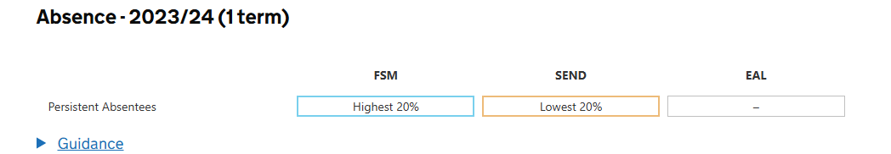

Externally provided programmes
Please include the names of any non-DfE programmes that you used your pupil premium to fund in the previous academic year.
Programme |  | Provider

Service pupil premium funding (optional)
For schools that receive this funding, you may wish to provide the following information: How our service pupil premium allocation was spent last academic year
The impact of that spending on service pupil premium eligible pupils

